Elucidation of Transporting Processes Times 14pt, bold, capital letters, centered, in upper and lower case, first letter capital

Tomáš Navrátil ¹, and Miroslav Fojta ²

¹ J. Heyrovský Institute of Physical Chemistry of the AS CR, v.v.i., Dolejškova 3, 182 23 Prague 8, Czech Republic, E-mail: Tomas.Navratil@jh-inst.cas.cz
² Institute of Biophysics and Biochemistry of the AS CR, v.v.i., Královopolská 135, 612 65 Brno, Czech Republic

Text text text text text text text text text text text text text text text text text text text text text text text text text text text text text text text text text text text text text text text text text text text text text text text text text text text text text text text text text text text [1, 2]. text text text text text text text text text text text text text text text text text text text text text text text text text text text text text text text text text text text text text text text text.
Text text text text text text text text text text text text text text text text text text text voltammetrically [3]. Text text text text text text text text text text text text text text text text text text text text text text text text.
Text text text text text text text text text text text text text text text text text text text voltammetrically [1-4]. Text text text text text text text text text text text text text text text text text text text text text text text text. Text text text text text text text text text text text text text text text text text text text text text text text text.

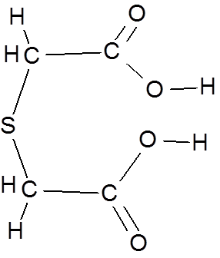
Fig. 1: Thiodiglycolic acid

References
[1] T. Navratil, I. Sestakova, K. Stulik, and V. Marecek, Electroanalysis 22 (2010) 2043.
[2] J. Newman, Electrochemical Systems, 2nd ed., Prentice–Hall, Englewood Cliffs, NJ, 1991.
[3] A.R. Hillman, in: R.G. Linford (Ed.), Electrochemical Science and Technology of Polymers, vol., 1, Elsevier, Amsterdam, 1987, Ch. 5.
[4] B. Miller, Proc.6th Australian Electrochem. Conf., Geelong, Vic., 19-24 Feb., 1984; J. Electroanal. Chem., 168 (1984) 91.

Acknowledgments
The research was supported by GA AV CR (project No. IAA400400806) and by GA CR (project No. P206/11/1638 and project No. P208/12/1645).

