46th Heyrovský Discussion

Molecular Electrochemistry
in Organometallic Science

Program

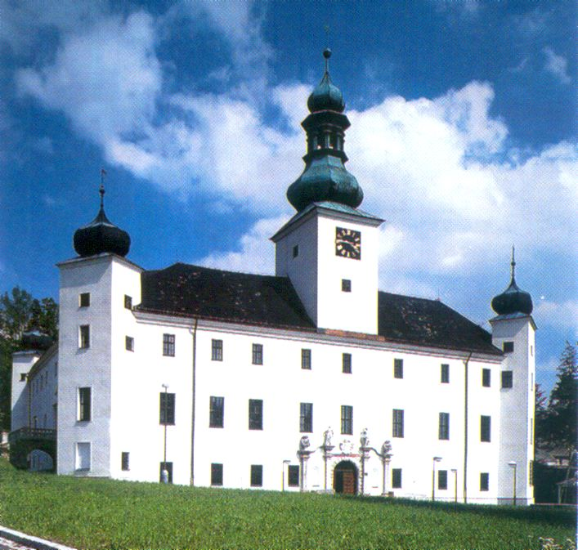

Castle Třešť (Czech Republic)
June 23-27, 2013

Programme

Sunday, June 23
10:00 | Refreshment, registration in the entrance hall of the J. Heyrovský Institute, possibility to leave the luggage and walk in the town
15:00 | Departure of a special bus from the J. Heyrovský Institute (Dolejškova 3, Prague 8 – Kobylisy)
17:30 | Arrival, registration at the Castle Třešť
19:00 | Welcome apéritif
19:30 | Dinner
Monday, June 24
from
7:00 | Breakfast
8:30 | Opening of the Discussion - Jiří Ludvík, chair
 | Electron and proton transfer
Time | Chairman |  | Speaker |  |  | Title of presentation
8:40 | R. Glass |  | J-M. Savéant |  | FR | Proton-Coupled Electron Transfer Catalysis of the Reduction of CO₂ to CO. Mechanisms and Reactivity  (introductory lecture)
9:30 |  |  | W. Kaim |  | GE | Identifying Intermediates of Sequential Electron and Hydrogen Loss from a Dicarbonylcobalt Hydride Complex
10:00 | Coffee break
Time | Chairman |  | Speaker |  |  | Title of presentation
10:30 | Masa-aki Haga |  | G. Passard |  | FR | Proton-Coupled Electron Transfer Cleavage of Carbon-Metal Bonds Exemplified by the Reduction of an Alkyl Cobalt Porphyrin
10:30 |  |  | B. Sarkar |  | GE | Electron and Proton Transfer Induced Reactivity in Metal Complexes Containing Redox-Active Ligands
10:30 |  |  | M. J.  Rosales-Hoz |  | MX | Transition Metal Carbonyl Clusters: Some Electrochemical aspects
10:30 |  |  | L. Martins |  | PT | Electrochemical Behaviour of Catalytic and/or Biologic Active C-scorpionate Complexes
10:30 |  |  | R. Ruppert |  | FR | Thirty Years of Molecular Electrochemistry : Some Examples
12:30 |  | Lunch
Monday, June 24
 | Afternoon session:
 | Electrochemistry of coordination compounds
Time | Chairman |  |  | Speaker |  | Title of presentation
14:30 | A. Pombeiro |  |  | A. Hildebrandt | GE | Electron Transfer Studies on (Multi)Ferrocenyl Five-Membered Heterocycles  (introductory lecture)
14:30 |  |  |  | O. Buriez | FR | Electrochemistry as a tool to map the activation sequence of organometallic ferrocene-based anti-cancer drugs
15:30 | Coffee break
Time | Chairman |  | Speaker |  |  | Title of presentation
16:00 | D. Lorcy |  | Liang Deng |  | CN | Redox Reactivity of Iron and Cobalt Complexes with Monodentate N-Heterocyclic Carbene Ligation
16:00 |  |  | P. Paraskevo-  poulou |  | GR | Trisamido-Amine Complexes that Undergo Metal- and Ligand-Centered Oxidative Transformations
16:00 |  |  | M. J. Calhorda |  | PT | Redox properties and DFT study of ReCp(CO)₂L (L = PPh₃, η²-2-butene, η-diphenylacetylene)
16:00 |  |  | A. Popov |  | GE | Endohedral transition metal and rare-earth redox couples inside the carbon cage: fullerene as an innocent ligand
17:45 | Concert (Prague Cello Quartet)
19:00  20:30  21:00 | Dinner  History and monuments of Jihlava town – destination of the Tuesday´ trip (information for interested persons in the conference room –  I. Hoskovcová)  Sausage party in the park

Tuesday, June 25
from
7:00 | Breakfast
 |  | Intramolecular electron communication
 |  | Morning session I :
Time |  | Chairman | Speaker |  |  |  | Title of presentation
8:30 |  | M. del J. Rosales-  Hoz | R. Winter |  | GE |  | ΔE_{1/2} as a Measure of the Electronic Coupling in Mixed-Valent Systems: Triumphes and Failures  (introductory lecture)
9:20 |  | M. del J. Rosales-  Hoz | A. Liška |  | CZ |  | Electrochemically generated tetranitrocalix[4]arene ligand
 |  | M. del J. Rosales-  Hoz | A. J. L. Pombeiro |  | PT |  | Redox Potential Parameterization in Half-Sandwich Coordination Compounds
10:10 | Coffee break
 |  | Morning session II :
Time |  | Chairman | Speaker |  |  | Title of presentation
10:40 |  | M. J. Calhorda | D. Lorcy | FR |  | Electronic Communication Between Tetrathiafulvalene Electrophores in Organometallic Complexes
 |  | M. J. Calhorda | B. Thierren | CH |  | Selective Sensing of Picric Acid Using Arene Ruthenium Tetrapyridyl-Tetrathiafulvalene Metalla-Assemblies
 |  | M. J. Calhorda | T. Mikysek | CZ |  | Electrochemistry of Ferrocene Based Charge-Transfer Molecules with a Systematically Extended π‐conjugated System
 |  | M. J. Calhorda | P. R. Mussini | IT |  | Rationalizing the electronic properties of two classes of push–pull DSSC sensitizers based on Zn(II) di- or tetrarylporphyrinates substituted in meso or β-pyrrolic positions: an electrochemical investigation
 |  | M. J. Calhorda | I. Hoskovco-  vá | CZ |  | Structure Effects Influencing Redox Properties of Fischer Aminocarbene Complexes
12:45 | Lunch
14:15 | Excursion by bus:  Gothic castle - Roštejn  Historical town Jihlava  dinner with degustation of traditional local beer
21:00 | Arrival to Třešť

Wednesday, June 26
from
7:00 |  | Breakfast
 | Morning session:
 | Molecular electrochemistry applications
Time | Chairman |  | Speaker |  |  |  | Title of presentation
8:30 | W. Kaim |  | P. J. Low |  | UK |  | From Electrochemistry to(wards) Electronics  (introductory lecture)
9:20 |  |  | M. Beley |  | FR |  | Transition Metal Complexes in Dye Sensitized Solar Cells
9:20 |  |  | Masa-aki Haga |  | JP |  | Surface Electrochemistry of Homo- and Hetero-multilayer Films of Dinuclear Ru Complexes toward Molecular Devices
10:15 |  | Coffee break
Time |  | Chairman |  | Speaker |  |  | Title of presentation
10:45 |  | M. Belley |  | C. Frontana | MX |  | Molecular Electrochemistry Studies of Organic Molecules for Special Applications: Spiro compounds, TEMPO/PROXYL derivatives and Nitroimidazoles
 |  |  |  | A. Deronzier | FR |  | Electro and photoactivable coordination polymers
 |  |  |  | H. Kvapilová | CZ |  | Combined Theoretical and Spectroelectrochemical Study of Valence Tautomerism in Tetracoordinated Copper Complexes
 |  |  |  | P. Machata | SK |  | In situ EPR-UV/Vis/NIR spectroelectrochemical studies of on M(III) complexes with dithiolene ligands
12:30 |  | Lunch
Afternoon session:

Time |  | Chairman |  | Speaker |  |  | Title of presentation
14:30 |  | Liang Deng |  | K. Moeller | US |  | From Microelectrode Arrays to Solar Driven Electrolyses: Recycling Chemical Reagents for Selective Synthetic Transformations  (introductory lecture)
 |  |  |  | M. Mellah | FR |  | Original Use of Electrochemistry to Generate SmI₂ Reagent for Electrosynthetic Applications
15:30 |  | Coffee break
Time |  | Chairman |  | Speaker |  |  | Title of presentation
16:00 |  | L. Martins |  | S. Arnaboldi |  | IT | Inherently chiral electrochemically active molecules and molecular materials: concept, strategy, potentialities
 |  |  |  | R. Holze |  | GE | Optical and Electrochemical Bandgaps in Oligomeric and Polymeric Systems – a Critical Review
 |  |  |  | W. Oberhauser |  | IT | Chemoselective Diol Oxidation in Organometallic Fuel Cells
 |  |  |  | R. Sokolová |  | CZ | Spectroelectrochemistry of Silybin and its Copper Complex
 |  |  |  | G. Meszaros |  | HU | Shot noise of electrochemical processes in the diffusion limiting region
18:00 |  | Walk around Třešť
20:00 |  | Farewell dinner

Thursday, June 27
from
7:00 |  | Breakfast
 | Morning session:
 | Electrochemistry of catalytic active molecules
Time | Chairman |  | Speaker |  |  | Title of presentation
8:30 | P. Paraske-vopoulou |  | A. Jutand |  | FR | Contribution of Electrochemistry to Organometallic Catalysis  (introductory lecture)
9:20 |  |  | M.-N. Collomb |  | FR | Efficient photocatalytic hydrogen production in pure water from a cobalt(III) tetraaza-macrocyclic catalyst. Electrochemical generation of the low-valent Co(I) species and its reactivity toward proton reduction
9:20 |  |  | M. Michman |  | IL | Comment on Selectivity and Catalysis in Electrochemistry
10:10 |  | Coffee break
Time |  | Chairman |  | Speaker |  | Title of presentation
10:40 |  | C. Frontana |  | C. Tard | FR | Transition Metal Chalcogenide Nanoparticles for Electrocatalytic Hydrogen Evolution
 |  |  |  | R. S. Glass | US | Electrocatalysis of H₂ Production from Weak Acids by (µ-pyrazine-2,3-dithiolato)diironhexacarbonyl
11:30 |  | Closing Remarks
11:45 |  | Lunch
12:45  16:00 |  | Departure to Prague  Expected arrival to the Prague Airport
note:

POSTERS SHOULD BE ON DURING THE WHOLE MEETING IN THE FOYER OF THE CONFERENCE HALL (No special poster session will be organized, discussion may proceed during coffee-breaks)

