The Title of the Submission
Jane Doe¹, John Doe¹
¹ Name of the institution, address, country.
email: j.doe@email.com
This is the template of the submission for ICSCIMS 2019. Submission should be one-page long, outlining your poster or oral contribution in a form of an abstract (500 – 1000 words), one representative figure including a brief caption, short acknowledgement and max. 3 citations. For References used the default EndNote “Numbered” style [1]. Font Calibri (Body) 10, single spaced, 6pt after each paragraph.
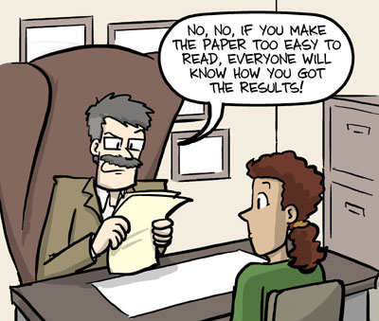
Fig 1: Description of the figure (reproduced from Jorge Cham, "Piled Higher and Deeper", phdcomics.com).
Acknowledgement
Acknowledgement, including all sources of funding.
References
1. Thomson, J.J., Cathode Rays. The Electrician, 1897. 39: p. 104.

